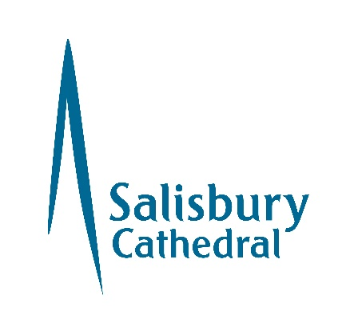

Salisbury Cathedral Volunteer Application Form
Please return this form to Christine Keegan, Wyndham House, 65 The Close,
Salisbury SP1 2EN or email c.keegan@salcath.co.uk

Full name
Volunteer role(s) applied for, if known
Address
Postcode
Home telephone
Mobile
email
Date of birth
Next of kin
Emergency contact

Your availability – please tick all that apply
MON  AM | MON  PM | TUES  AM | TUES  PM | WED  AM | WED  PM | THUR  AM | THUR PM | FRI  AM | FRI  PM | SAT  AM | SAT  PM | SUN

Information to support your application (experience, skills etc)
There will be occasions when we may call upon you and it will be helpful for us to know your skills, relevant working life or experiences.
In addition and separate to our volunteering roles, we are also keen to know about skills you have which may be useful to the governance of the Cathedral. Examples include (but are not limited to) strategy, finance, human resources, communications, safeguarding, property, risk, environmental sustainability, visual arts. We may be in touch at a time in the future to discuss these with you.

Have you interest in any of the specialist subject knowledge listed below? Please tick the appropriate box(es)

Architecture |  | Embroidery
Art |  | History
Stained glass |  | Gardening
Foreign languages. Please give languages and standard
Further specialist knowledge/qualifications

Cautions and Convictions
The amendments to the Exceptions Order 1975 (2013) provide that certain spent convictions and cautions are ‘protected’ and are not subject to disclosure to employers and cannot be taken into account.
Guidance and criteria on the filtering of these cautions and convictions can be found on the Disclosure and Barring Service website.
Do you have any convictions, cautions, reprimands or final warnings which would not be filtered in line with current guidance?
Yes No
If yes please give details on a separate sheet.
References
Please give names and addresses of two referees, making sure that they are not personal friends or family members (suitable referees will include former employers, teachers etc or independent people who can give a view as to your experience or character).
 | Referee  one | Referee  two
Name
Address
Telephone
Email (essential)
Capacity in which you know this referee

Safeguarding and DBS
We are committed to the safety and welfare of the everyone within our Cathedral. Therefore, if you are applying to volunteer with us and your application is accepted, it may be necessary for you to complete a Disclosure and Barring Service check. You will be required to carry out basic safeguarding training.

Data Protection Act

The information that you provide on this form and that obtained from other relevant sources will be used to process your application for volunteering. The personal information that you give us will also be used in a confidential manner to help us monitor our recruitment process. If you succeed in your application and take up volunteering with us, the information will be used in the administration of your volunteering with us. We may also use the information if there is a complaint or legal challenge relevant to this recruitment process. We may check the information collected against other information held by us or with third parties. By signing this application form, you give your consent to the processing of personal data, as described above, in accordance with our registration with the Information Commissioner. If you are successful then the information will remain on your file for the duration of your volunteering, if your application is unsuccessful your application will be kept for 6 months and then destroyed.

Declaration

I understand that any offer of volunteering with the Cathedral is subject to the satisfactory receipt of documentation including references and a possible DBS check and is binding in honour only.
In accordance with the 2018 Data Protection Act I agree that the Cathedral may hold and use personal information about me for volunteering reasons and to keep in touch with me. This information including that contained in this form can be stored on either manual or computer files. It will be held securely and only accessed by authorised personnel.

Signature
Signature:
Date:

For office use only

Interview date
Start date
Interviewer comments

If new volunteer
Confidential Declaration Form return date

Accepted to the following Volunteer Group(s)

tick all boxes that apply
Floor guide – state team
Tower guide |  | Community |  | Education
Events |  | Cathedral shop |  | Cathedral flowers
Holy Duster |  | Embroiderer |  | Guild of Stewards
Concert steward |  | Sunday coffee |  | Sunday Club
Chaplain/LLM
Worship – state role
Other – give details

Please return this form to Christine Keegan, Wyndham House, 65 The Close,
Salisbury SP1 2EN or email c.keegan@salcath.co.uk

We will never use your data for any purpose other than that for which you gave it to us without your permission See www.salisburycathedral.org.uk/privacypolicy

